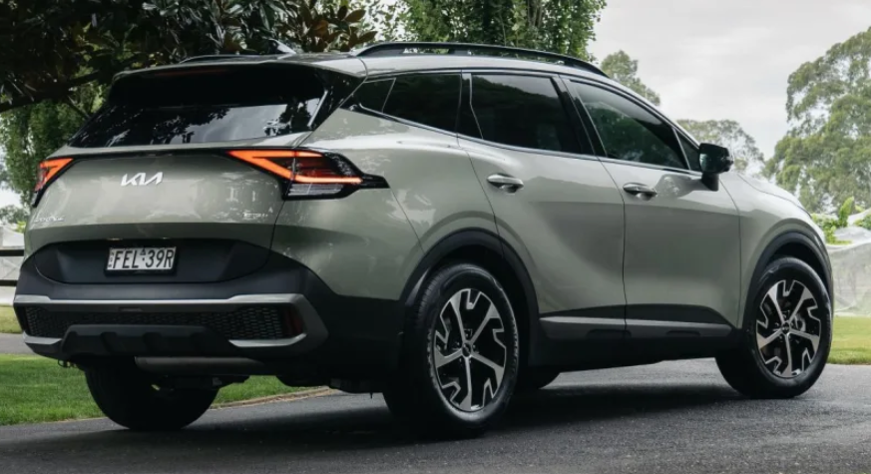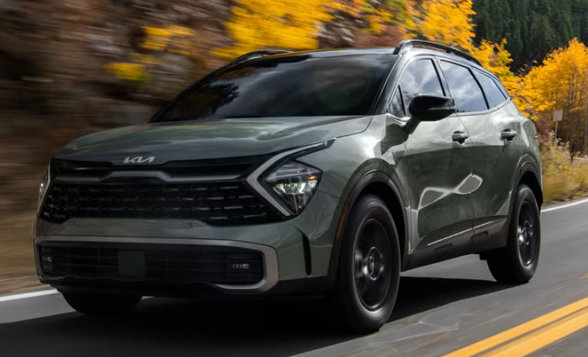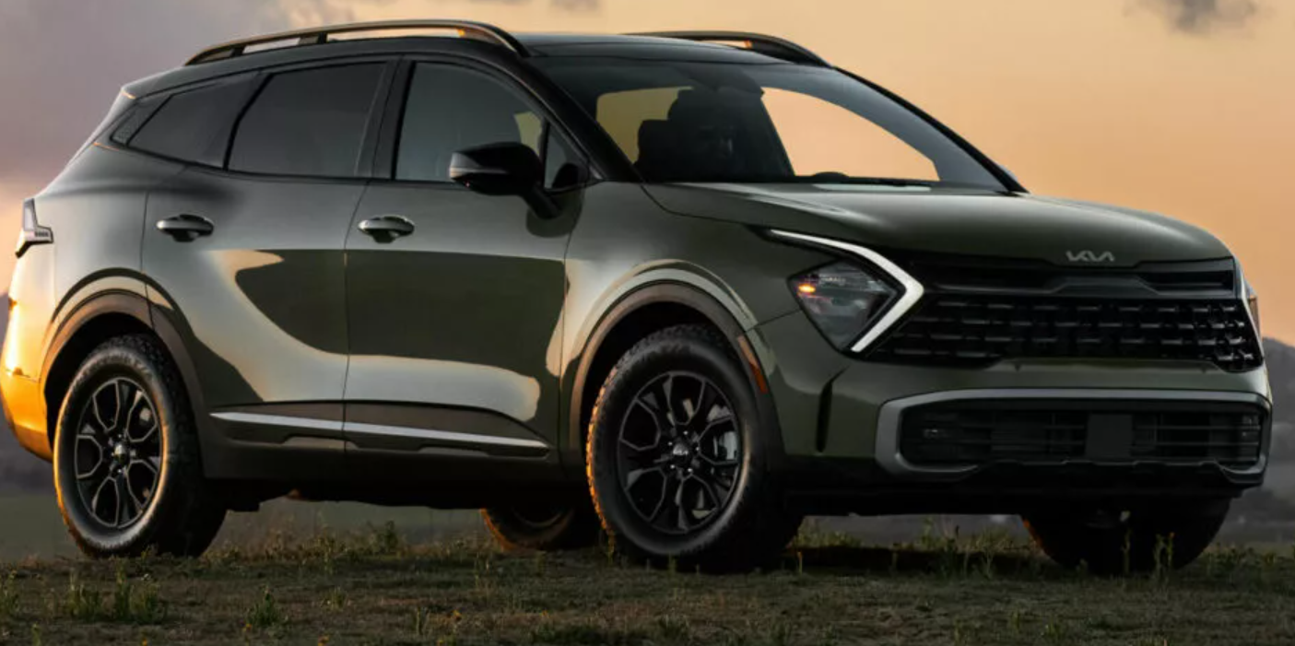

**Main Specifications** of the **2025 Kia Sportage**

**🚗 Powertrain Options**

1. **2.5 L Naturally Aspirated I4**
   * Power: 187 hp @ 6,100 rpm
   * Torque: 178 lb‑ft @ 4,000 rpm
   * Transmission: 8‑speed automatic, FWD or AWD
2. **1.6 L Turbo-Petrol I4** (markets outside U.S.)
   * Power: ~180 PS (~178 hp) @ 5,500 rpm
   * Torque: ~200 Nm (~148 lb‑ft)
   * Transmission: 7‑speed DCT (now replaced by 8-speed auto)
3. **1.6 L Turbo Plug-In Hybrid (PHEV)**
   * Combined output: ~261 hp, 258 lb‑ft torque
   * 13.8 kWh battery; EV range ~34 mi
   * Transmission: 6‑speed automatic
4. **1.6 L Turbo Mild-Hybrid / HEV**
   * Combined output: ~227 hp, 258 lb‑ft torque
   * Transmission: 6‑speed automatic; FWD/AWD

**📏 Dimensions & Capacities**

| **Specification** | **Metric / Imperial** |
| --- | --- |
| Length | 4,661 mm / 183.5 in |
| Width | ~1,865 mm / 73.4 in |
| Height | 1,654–1,699 mm (65.4–66.9 in) |
| Wheelbase | 2,755–2,756 mm / 108.5 in |
| Ground Clearance | 180 mm / 7.1 in (varies by trim) |
| Curb Weight | 1,535–1,700 kg / 3,387–3,732 lb depending on model |
| Cargo Volume | 39.6 cu ft (~1,121 L), max ~74.1 cu ft (seats down) |
| Towing Capacity | 750 kg unbraked; 1,653 kg (~2,500 lb) braked |

**🛣️ Performance & Efficiency**

* **2.5 L**: 0–60 mph in ~9.1 s (AWD)  
  EPA: ~25 mpg combined (23 city / 27 hwy)
* **1.6 L Turbo PHEV**: 0–60 mph in ~6.9 s; top ~124 mph; EV range ~34 mi; efficiency 84 MPGe combined
* **Hybrid (HEV)**: Combined output 227 hp; efficiency ~38 mpg; city/highway ~38/38 MPG

**🧭 Chassis, Suspension & Wheels**

* **Suspension**: Front MacPherson strut; rear multi‑link
* **Brakes**: F/R disc; ABS, EBD, brake assist standard
* **Wheels/Tires**: 17″–19″ alloys with 235 series rubber, depending on trim

**🛋️ Interior & Tech Highlights**

* **Infotainment**: 8" touchscreen; higher trims offer dual 12.3" digital displays (infotainment + instrument cluster)
* **Connectivity**: Wireless Apple CarPlay/Android Auto, Bluetooth, USB-C, steering-wheel controls
* **Comfort**: Cloth or optional leather, heated/ventilated seats on GT trims; dual-zone climate control
* **Safety**: Advanced driver aids — lane-keep, blind-spot, forward collision‑avoidance, adaptive cruise (on higher trims)

**🔧 Warranty**

* Basic: 5 yr/60 k mi
* Powertrain: 10 yr/100 k mi
* Roadside assistance: 5 yr/60 k mi

**🏅 Market Popularity & Updates**

* One of the UK’s top-selling SUVs in 2025 ecent facelift features bold front styling, “star-point” LED lighting, refreshed bumpers, and upgraded interiors on trims (Pure, GT‑Line, GT‑Line S)

**✅ Summary**

The 2025 Kia Sportage is a versatile compact SUV that caters to various needs:

* **2.5 L** petrol: reliable, well-rounded everyday choice
* **1.6 T HEV**: excellent fuel economy (~38 MPG)
* **1.6 T PHEV**: strong power (261 hp) with ~34 mi EV range
* Safety tech, modern interiors, and generous warranty bolster its appeal